Example of the curriculum around Forming a learning team
Engaging the students in creating a learning team… like a sports team
Mission:
- Get students excited about learning (life-long learners).
- Have the reasoning skills to manage in today’s society and begin to build a set of skills for the future
- Understand that problems are opportunities.
LEARNING OUTCOMES / OBJECTIVES:

By the end of all the modules of this course, the students will be able to:
- Clearly articulate the nature of technology/engineering as defined in the Framework
- Use creative design process such as brainstorming, brain-writing, and morphological Analysis
- Understand how simulation software is used in design and analysis.
- Explain the relationship of skills she has and those needed to be developed
- Provide examples of the types of tasks that engineers perform
- Describe the steps of the engineering design process
- Understand the process of starting a company around the repair business
- See recycling and repair as a societal goal for improvement in making the world better.

In addition, the student will advance in:
Knowledge: As a result of the learning experiences in the course, you will become more cognizant of:
- Both creative and critical thinking methodologies
- Use of feedback and assessment in learning
- Using engineering design to create an interdisciplinary learning environment

Skill: As a result of the learning experiences in the course, you will become better able to:
- Use of brainstorming, brain-writing and morphological analysis
- Using the design process as described in the Framework
- Finding design challenges in stories that students read

Caring: As a result of the learning experiences in the course, you will become more competent in your ability to:
- Acceptance of mistakes as a learning experience
- Work collaborative with your fellow candidates.

Ethical: As a result of the learning experiences in the course, you will become more competent in your ability to create a learning environment that fosters ethical relationships.
Course Requirements – Candidates will read all the assigned material and do the expected projects per the scheduled assignments. The quality of the work shall demonstrate a focus on improving thinking skills and the engineering methodology. Course participation and the use of questions for engagement will be evaluated during projects.
Course Expectations – Candidates are expected to participate in the discussion forum and complete the assigned projects on time. Students are responsible for making arrangements with the instructor when difficulties arise in completing an assignment on time. A set of Rules of Engagement for the class will be published for student use. Grading rubrics will be used for evaluating each of the assignments, team assignments and discussion board postings.
Course Rubric: See attached rubric for this course.
Feedback Criteria: - Candidates will be assessed based on many classroom activities and their personnel effort put into both their success as well as supporting a learning environment. Major breakdown of these are shown below:
Activity | Discussion | % of total
Individual assignments | This includes developing lesson plans, writing a paper and creating design challenges from stories. | 30
Team assignment | Ability to work with others, communication skills, being able to give constructive feedback. | 25
Classroom discussion | This also includes on-line discussion boards. | 25
Supporting a learning environment | This measures the attitude of the individual in making suggestions, taking risks in activities, and supporting the learning atmosphere. | 20

Class Structure & Methods
One-hour Class Period Structure  - 15 min. of class learning/discussion  - 30 min. of Exercise / Activities by the teams  - Break | Class Activities ... Tied to the curriculum  - Improv.  Drawing exercise  - Problem solving  - Team building games  - Socratic Questioning
Student ownership | Facilitation
Creating teams- Like a Sports/Music team:
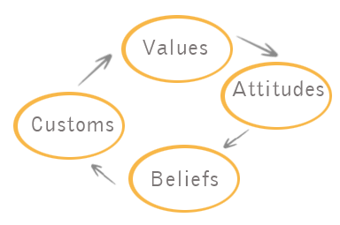
… Listen to each other; become a learning team… What is our culture?
- Overview of the project
- Measurable team goals, roles, deliverables
Create a team charter, The Charter Covers:
- Goals ( Fun, ….),
- How will we be measured at the end,
- Roles that the team will do, (Scribe, Captain, Planner, Advisor, Tester, Public reporter, )
- Our values, … Curiosity, Trust, Flexibility ,,,
- Deliverables?
- How will we handle conflicts?

teaching students to work in teams is one of the most important goals of a twenty-first-century teacher
- How should it operate?
- How does it compare to a sports team?
- What are our roles?
- How am I successful?
- How do we communicate and collaborate together?

Student Engagement
First I want to thank all the people here at the center for giving me the opportunity to meet and work with you. I have this vision but I need partners to make it real. But first we need to figure out how we will work together and what my idea is.
I have this idea to improve learning opportunities for students by infuse life skills (Thinking & Social) into a program that uses a problem solving process.
Why am I doing this? … Being an old man, I have seen how our world is changing and especial in the business field. We don’t change jobs but we change careers and the world of robots and AI is rapidly approaching. What does Google call it? ____________
You need new tools to survive and excel.
We need to see everything we do as providing our customers with the best service and products. My goal is to make students better at interfacing in Society, Educational and Business organization and become life-long learners. To do this, I need your help and support.

But first We need to develop trust, honesty, loving kindness and respect between us to move forward. Let me show you an outline of my process ….Look at the Web site Does this make any sense to you/ any questions or discussion?

Since this is about you, I want and need you to be an activity participant in this process. I need your commitment to do this.
If so, I need to understand more about you and your past learning

Student Engagement: Have a discuss about the following;
Why do you think its important to learn life-skills? What key words would they use to describe them? Have you use them in a sports team?
Ask the students:
- What classes have you had that made you feel good about learning?
- What was it about it that was right?
- If they have no answer, what teacher did they have that did not help them and why?
- Why do they think it is important for them to be good learners?
- Identify your highest hopes and deepest fears in life?

Recognize that you own your learning and are responsible for its success
Think of yourself as in your own business of learning,. What are you going to do to be successful?

“Students need to change their disposition toward school away from being directed by someone else to an attitude of working for your-self—agency, self-discipline, initiative and risk-taking are all important on the job.”
students should use a to-do list, develop a personal learning plan and create a portfolio of their best work
They learn to self-manage their time, reflect on how things are going again the plan and how-to check-in when they know they need support.
Our commitment to the student:
We are firm on expectations and principles but flexible on pathways give students time to engage deeply and opportunities to succeed and fail, and support the development of self-direction.
High engagement schools start from a different conception—knowledge co-creation and active production. They design a very different learner experience and support it with a student-centered culture and opportunities to improve self-regulation, initiative and persistence—all key to self-directed learning.

Begin:
Getting to know you as partners in my development of Project Academy.
- How do you feel about this learning? Can you relate it to your experience in school?
- Feedback from Questionnaire 6/28/2017
- Careers at this stage of your lives

Forming the team |  | Skills
Team:  Like a sports team | Diversity, Values of a culture,  Time management, Listening skills,  Collaboration Character development

Overview
- Play first https://youtu.be/f9LM88h-l-U  “The bigger the problem, the bigger the opportunity” (Vinod Khosla).  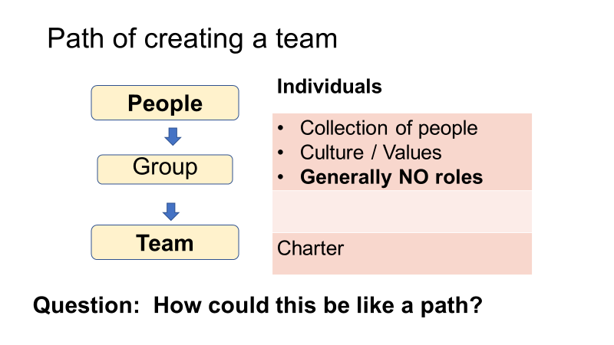 | Do Organizations have a Culture?
- Community Culture?  Discussion of the elements of the community culture  What are the boundaries?  Could this add value to anybody?  Write up the results  How is it discriminated to the public? | The school will foster a Team/community based culture of a learning environment, with all treated as adults and with respect. What is our classroom culture? (How are we going to operate?)  - Possible values are: (SB values)  Trust, Respect, Empathy, Kindness, Curiosity, Innovation, Persisting, Flexibility, Continuous learning, Humor and Taking responsible risk
Questioning: Make the conversation more relevant. Our students should understand the nature and make up of questions and how to use them in the learning/ conversation mode.  - What values do we want for our learning team?  - What issues can occur in our team?  - What roles do we want to play in this team?  - How does diversity help / not help the team?  - What benefits does a team approach help in solving problems?  - How are we going to work together – handle conflicts | Modified Culture  The school will foster a Team/community based culture of a learning environment, key values and treating all as adults and with respect. The community will operate will the following norms:  - Build bridges and learning from other societies  - Working towards stretch goals  - Measurements are for learning and continuous improvement  - Making the world a better place  - Loving Kindness … from the heart  Outcomes:  - Students will know the elements of a culture and apply that knowledge to various organizations  - Students will be able to construct a culture around a learning team
Discussion about what community / education / world problem we want to work on  Major Problem / what part of it / our reason | Skills  - Meta-cognition … Thinking about our thought process  - Character traits  - Curiosity  - Open-mindedness  - Citizenship includes social responsibility, loyalty  - Empathy, Loving-kindness and Hope

Classes:
Class title | Description | Life-skills
Class 1 | Introduction … split in groups & write what is a team
Class 2
Class 3
Class 4
Class 5
Class 6 | Celebration, Reflection

